|  |
| --- |
| colored transparent rectanglebusiness center imagecolored transparent rectanglecolored rectangle  Market Analysis |

|  |
| --- |
|  |

|  |  |
| --- | --- |
| Word count:  Email [Email Here] | [Related image](https://www.google.co.uk/url?sa=i&rct=j&q=&esrc=s&source=images&cd=&ved=2ahUKEwjl0NbNlLfjAhXt2eAKHW9xDSAQjRx6BAgBEAU&url=https%3A%2F%2Ftargetjobs.co.uk%2Fpostgraduate-providers%2Fhenley-business-school&psig=AOvVaw3e3AahdusNKjtGsEqepmc2&ust=1563288114293716) |

REMF48-18-9A

be832924

Contents

1.0 Executive Summary2

2:0

10:0 References17

Executive sumary

Fund aim/ stratergy

Investment stratergy

Risk measurement

|  |
| --- |
|  |

[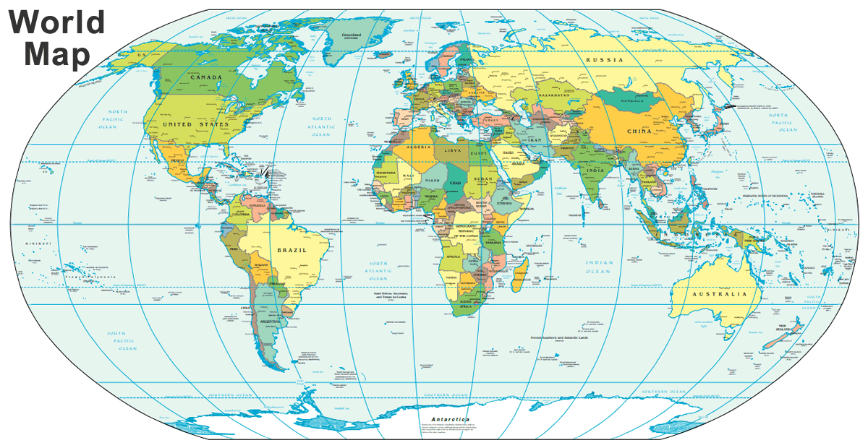](https://www.google.co.uk/url?sa=i&rct=j&q=&esrc=s&source=images&cd=&ved=2ahUKEwis4Z-_ia3jAhUAAmMBHSEBCxAQjRx6BAgBEAU&url=https%3A%2F%2Fgeology.com%2Fworld%2Fworld-map.shtml&psig=AOvVaw2HTfVh0lfV8oCryInFbz4P&ust=1562941643451332)

|  |  |  |
| --- | --- | --- |
|     **Overview**  Situated in the most southern part of Africa, South Africa has 1,739 miles of coastline, five neighboring countries; Namibia, Botswana, Zimbabwe, Mozambique and eSwantini as well as surrounding Lesotho, an enclaved country (worldatlas, 2019). South Africa has three capital cities: Cape Town; the legislative capital, Bloemfontein; the judicial capital and Pretoria; the administrative capital which is also often referred to as KMMthe main capital city (Rosenberg, 2019).  KEY FACTS   * 3 capital cities: Cape Town, Bloemfontein and Pretoria * No restriction on foreigners owning property * Population of 58,079,426 * Population density of 48 people per Km² * Median age is 26.3 years old   (worldometers, 2019)  A picture containing text, map  Description automatically generated  **Overview** | |  | | --- | |  | |
|  |

Project Brief

5,000 word guide

Due: September 1st

Portfolio already has:

* Class A offices
* Dominant shopping centres

Aim:

* Take on more risk through non-core locations and assets

Objective:

* Take advantage of emerging dynamic sectors
* Generate more income
* Invest this coming year

Task:

* Show how risk measured
* Show how opportunities are measured
* Give recommendations for:
  + - Locations to invest in
    - Sectors to invest in

Outcomes:

Part A:

Countries

1. Pick two countries of my choice
2. Provide brief analysis of recent performance/ trends of prime assets (office/ retail) in core locations – this will be used to benchmark and compare for later analysis

Part B:

Identify investment opportunities in:

1. Non-prime assets in core locations
2. Prime assets in secondary locations
3. Alternative real estate investment sectors

Part C:

Analysis should consider:

1. Secondary assets (office and retail) in core locations
2. Good quality assets (office and retail) in two secondary cities for each country (4 assets in total)
3. Two from the list below of alternative real estate investment opportunities (these must be the same two for both countries):

* **Leisure**:

(bars, restaurants, cinemas, theme parks, theatres, gyms, bowling alleys, spas and sport facilities)

* **Hotels:**

(budget or luxury)

* **Institutional grade residential**

(build to rent BTR and senior housing)

* **Student accommodation**
* **Healthcare**

Part D:

1. Interpret risk for the sector/ location
2. Interpret opportunities for the sector/ location
3. Analyse the fundamentals **(market drivers)** underlying the markers AND real estate types
4. Support analysis with price information
5. If analysis says it is not worth taking on the risk in the countries it is IMPORTANT to argue the case well and say why it is better to stick to core
6. Highlight sectors that have the potential to become mainstream investor sectors in the near future (client will appreciate non-conventional recommendations)

Assessment criteria:

- Evidence of research

- Evidence of understanding market fundamentals and assessment of opportunities and risks

- Comparative analysis

- Clarity of argument

– use section summaries

– SWOT (Strengths, Weaknesses, Opportunities and Threats) analysis for comparing investment strategies

– tables etc.

- Convincing, well-developed professional recommendations

Canada

South Africa

Seychelles

Saudi Arabia

* Chosen countries as variation in GDP world ranking according to (World Population Review, 2019)
  + Canada = 10
  + South Africa = 36
  + Saudi Arabia = 20

How to manage risk in real estate investment (Parsley, 2018)

* **Larger mega-themes (things not related to economic cycles)** 
  + Student houses
  + PRS (private rental sector)
  + BTR (build to rent)
  + Micro living
  + Co-working concept
* Long term income
  + Hotels
  + Student accommodation
* Industrial sector has been improving over the past 12 months
  + Investors think they will see future rental growth
  + Yields have fallen
* Bulk good stores are still doing well such as lidl and aldi
* Key issues for managing risk:
  + Focus on centres where people:
    - Work
    - Play
    - Live
    - Learn
  + Capital preservation
  + Pre-let 25% to make sure theres income
  + Real time reporting to help preserve capital and maximise returns

Risk

* Value at Risk (VaR)
* Beta
* Standard deviation
* Systematic risk management
  + Associated with the market
  + Mitigated through hedging

Project

* Market analysis
  + Why invest in these countries
  + Ease of doing business.

Investment philosophy

* **Diversification** 
  + Different continents
  + Investing globally can hedge against currency risks
  + Prospectively improve overall returns
  + One G7 country (Canada)
  + Saudi Arabia
  + Mongolia (14th fastest GDP growth)
  + Active management to improve investment outcomes

Country selection process

* Based on growth prospects
* Long term investments (held for at least 5 years)
* Diverse portfolio to minimise risk

<http://cbre.vo.llnwd.net/grgservices/secure/2019%20CBRE%20POOC_Q9bx.pdf?e=1562945116&h=3e972b3d64247a3b2e51214eca4bffe0>

selecting a country

* Could do china and pick hema saving retail
* Seoul

SAUDI ARABIA NOTES

(Majdalani, 2019)

* GDP is set to continue rising
* Average growth of 2.2% GDP in the next five years
* Lack of high quality stock therefore key office schemes continue to out perform the market
* Hospitality market its forecasted to increase in popularity
* Rental trends have decreased

Reasons to invest globally

(Bhalsod, 2018)

* Benefits of going global:
  + Risk reduction
  + Return enhancement
* **The 4 main benefits of adopting a global approach** 
  + **Diversification of macro and property market risk**
  + **Improve risk-adjusted retuns allowing targeting of an income return**
  + **Opportunity to target strategic timing of international property cycles**
  + **Access to a large and more diverse opportunity set**

**1) look at what the portfolio already has and question if it has liquidity risks/ economic stability risk/ economic resilience/ economic stability/ financial risk/ external risk/ political risk/ transparency/ liquidity/ volatility**

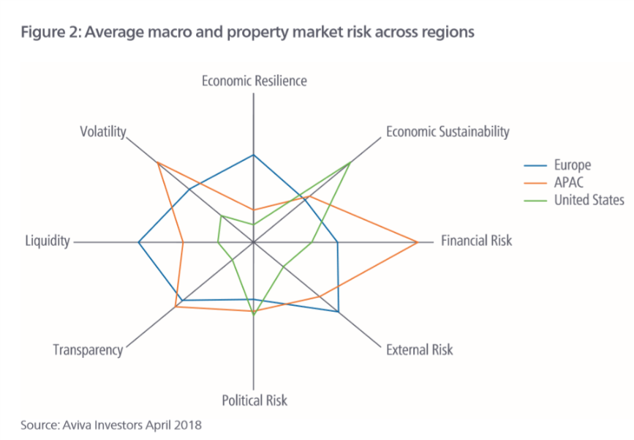

**Concordance in Global office Market cycles**

(Alexy Akimov, 2014)

* D’Arcy et al., 1997 shows the importance of economic fundamentals in determination of both retail and capital values
* **Conner & Liany (2005) shows** the average correlation between US stock market and foreign markets is 0.7. the average US GDP is only 0.19 ; therefore fund manager should diversify globally
* **Harding & Pagan (2006) the measure used BBQ method**

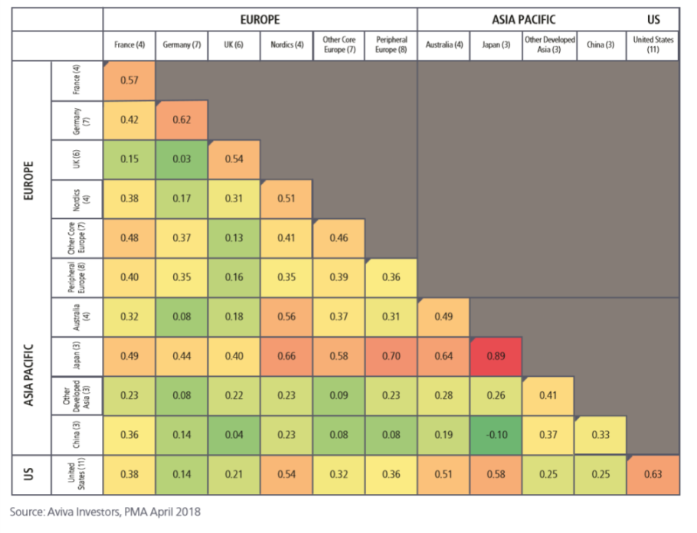

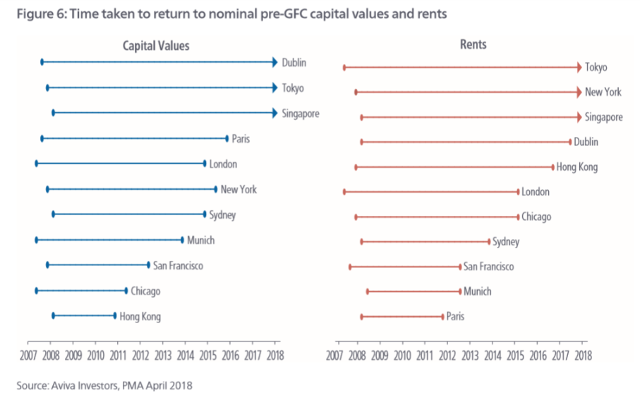

* **I think the aim is we want:** 
  + **Two countries that show concordance**
  + **Diversified via continent**
  + **Different economic cycles**
  + **One developing world country as “ it is expected that they will experience a much faster growth in investable stock that mature markets”**
  + **Look for the JLL transparency scores**
  + **Look to invest using different types of capital**
  + **Cyclical approach through active management**
  + **Four quadrant approach** 
    - **Further diversification via** 
      * **Size of building costs of buildings**

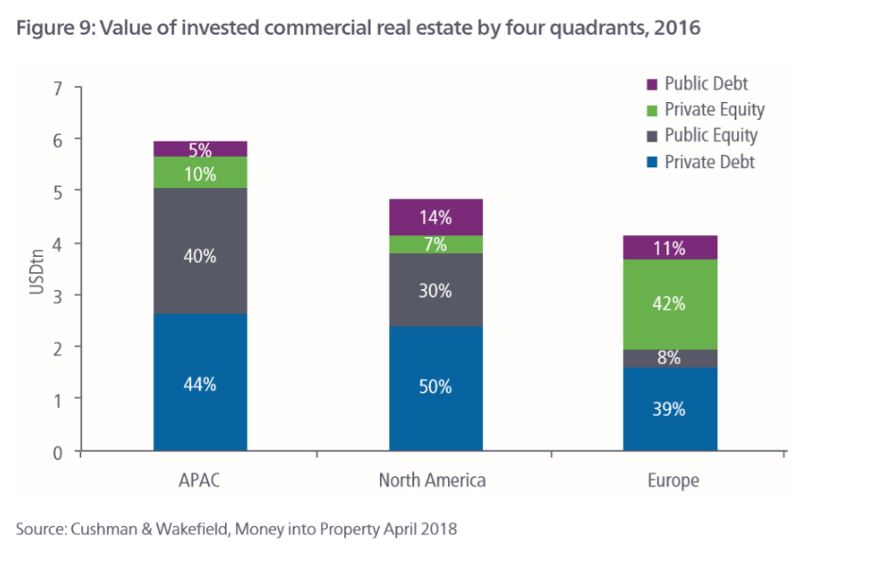

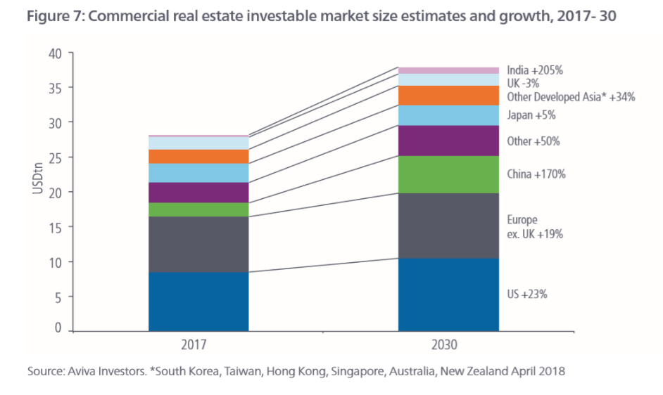

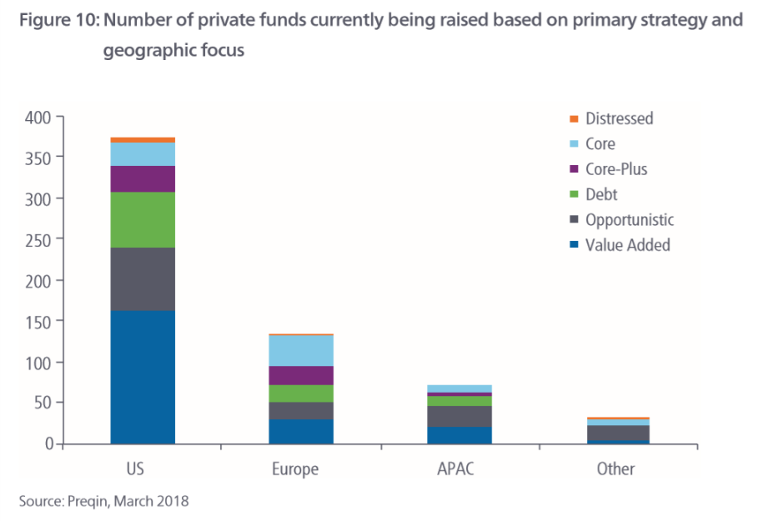

**Improving real estate performance through global diversification**

(Standard, 2019)

* Take advantage of mispring in core, non-domestic markets
* Indirect for smaller firms
* Direct investment for bigger firms
* **Things to consider:**
  + **Taxes**
  + **Fees**
  + **Currency**
  + **Leverage**
  + **Risk**
* Currency hedging to avoid currency fluctuations
* Diversifying allows access to some sectors that are otherwise not allowed in certain countries as well as strategy opportunities
  + Student accommodation
    - * + Both /\\/ have grown the most in recent years
  + Retirement homes
* 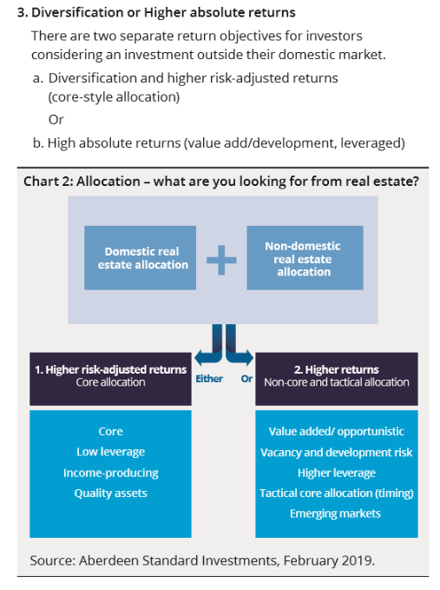
* 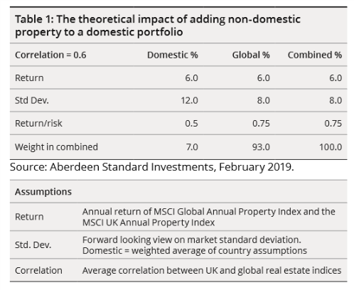
* **Look for asset specific risks:** 
  + Location
  + Sector
  + Tenant
  + Buildings
* Higher unequal lot sizes means higher number of assets to reduce the risk
* 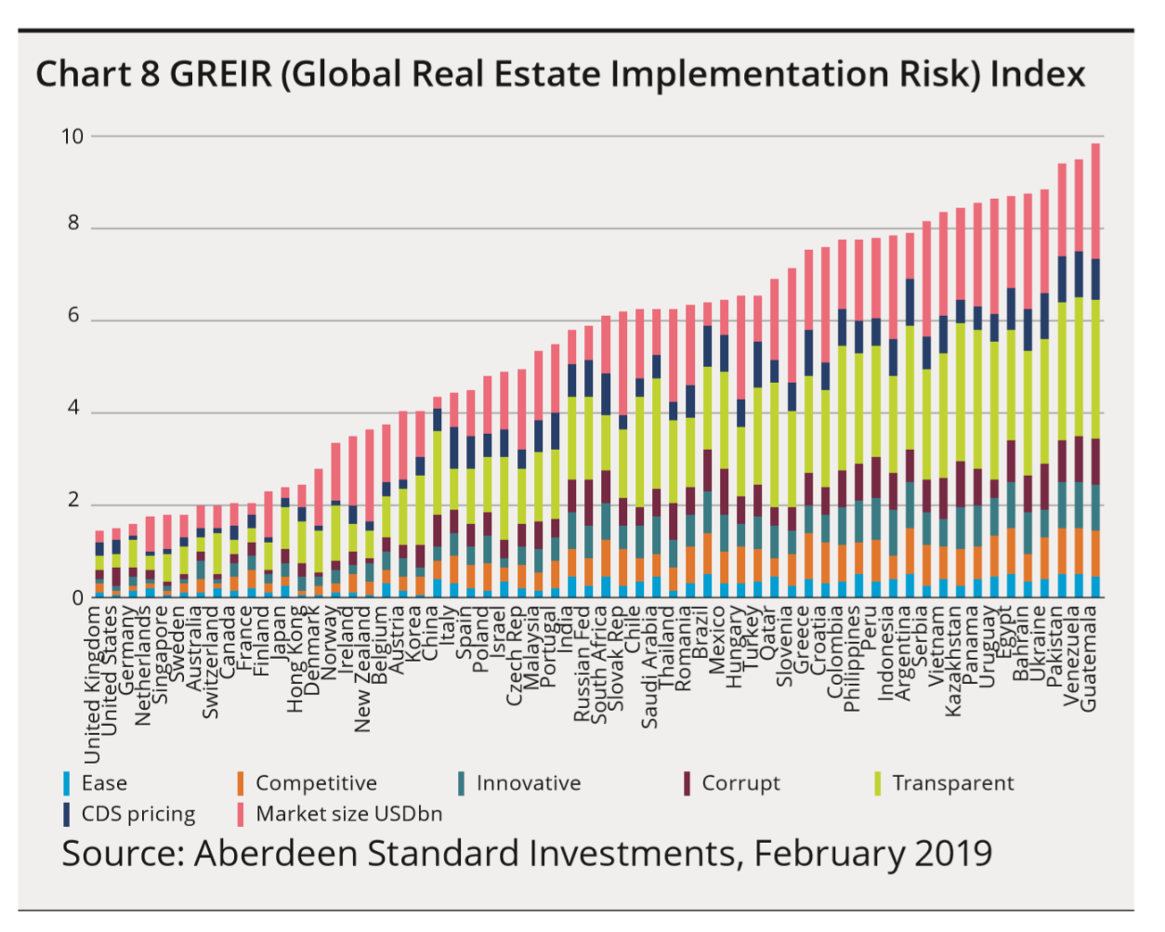Look for REITs/ unlisted real estate funds and funds of funds
* https://www.prsgroup.com/regional-political-risk-index-4/ **Asian political risk source**
* Looking at different types of capital investment opportunities
* Active management
* Using a developing world country as “it is expected that they will experience a much faster growth in investable stock than mature markets”
* Size of buildings
* Use of buildings

Other things considered included

* Taxes
* Fees
* Currency
* Leverage

|  |
| --- |
| 3:0 Country Profiles |

3:0 Selection stratergy

In order to pick the countries that would provide the good returns for the investment stratergy, CJCH have aimed to mitigate risk though diversification. CJCH have strategically chosen countries that are in different continents in order to mitigate any risks that would be faced if the portfolio was localised. CJCH have chosen Canada in the continent of North America and Singapore in the continent of Asia. These two continents were chosen due to their economic cycles being very similar to one another (Aviva, 2018). This means that as one countries economy increases in momentum, the other follows in pace shortly afterwards. This selection technique allows for strategic timing of holding periods in order to maximise revenue from the invested countries.

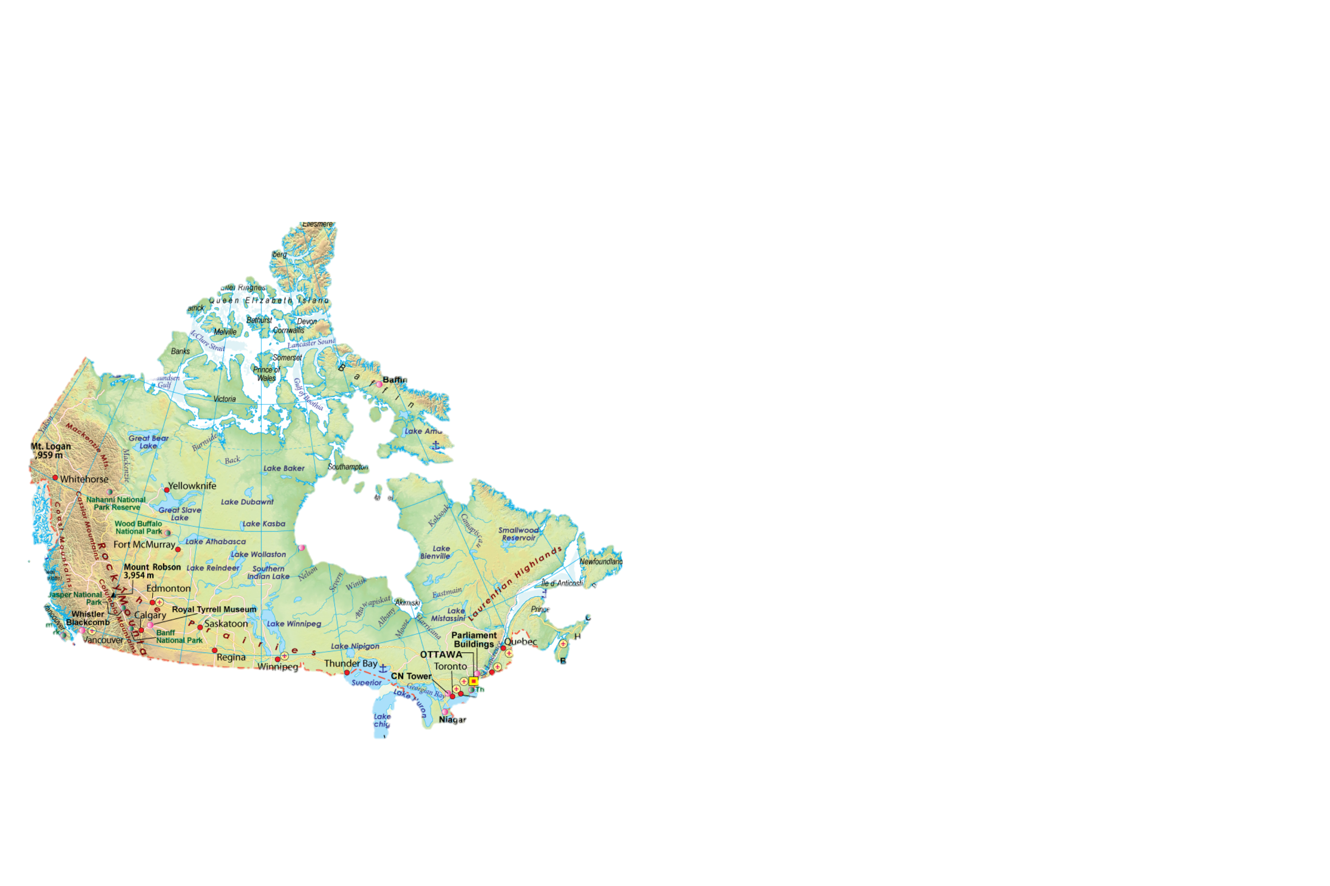CJCH also believe these markets are stable and have little political risk. Singapore and Canada also have attractive opportunities that will suit the need of our client.

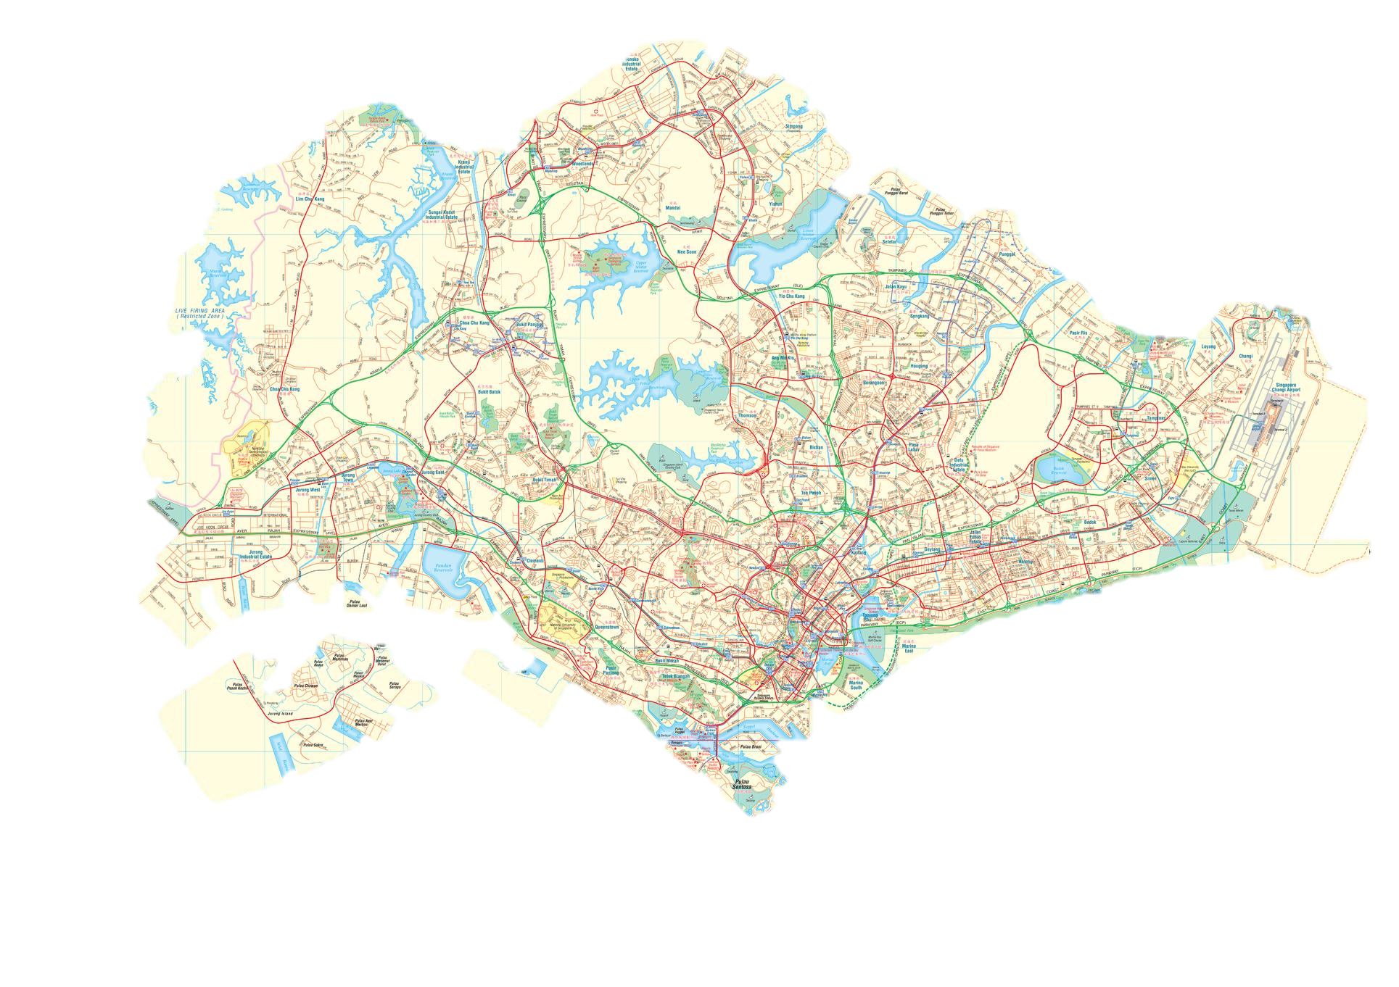

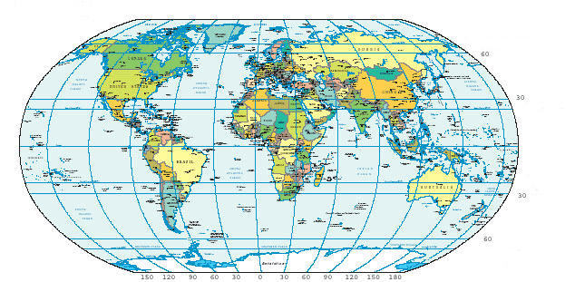

Figure : location of selected countries. Left - Canada and right - Singapore

3:1 Risk Assessment scale

In order to quantify risk throughout the report, a risk chart has been derived to assess low, medium and high risk. The countries and assets will be assessessed on the following criteria: Economic resilience, sustainability, investor growth, political stability and transparency.

* **Low risk = score of 0 – 1**

* **Medium risk = score 2 -3**

* **High risk = score 4 -5**

Figure : The Risk Assessment Chart

3:2 The Global Financial Crisis and Economonic resilience

3:2:1 Canada

Unlike most industrialised countries in the Global financial crisis, Canada had stregths which permitted it to weather the crisis better than the majority of other countries. Canada got through the financial storm relativly unscathed compared to the U.S and European countries. This was due to factors such as having a diversified banking system. Canada have adopted the “Universal bank” model which has allowed canadian banks to remain rather stable with healthy loan to deposit ratios. This is due to the model inheretly balancing assets and liabilities – the bank collects deposits from individuals and businesses and lends to both (Downe, 2010). This meant that though property had to be repriced it was not as significantly impacted as other European countries and the U.S (Gordon, 2017).

CJCH would regard Canada to have a high economic resilience as the impact of the global financial crisiss was not as hard to Canada as to other industrialised countries. This was due to factors such as the universal banking system having already evolved into the Canadian banking system, which provided protection for when the crisis hit. It is for this reason that we would give Canada 5 for economic resilience on the risk scale (see Figure 1).

3:2:2 Singapore

Singapore was the first east asian country to fall in a recession following the global financial crisis (Thagavelu, 2008). Though Singapore was impacted by the global financial crisis, their government was able to implement the Skills Programme for Upgrading and Resillience (SPUR) to recover from the recession quickly. SPUR allowed the Singaporean citezans to take programmes to acquire skills and knowledge in order to get jobs that would help speed up the economic growth of the country (Killiguou, 2010).

CJCH believe that though Singapore was able to recover from the global financial crisis quickly compared to other neighbouring countries; therefore, making Singapore a very buoyant and resilient country compared to other east asian countries. CJCH regard Singapore to be of medium to high economic resilience; thus, a score of 3 on the risk scale (see Figure 1.).

3:3 Sustainability

In order to better understand each countries sustainability levels the Brundtland (1987) definition has been adopted. This definition states that sustainabile practices should be used socially, economically and environmentally in order to

3:3:1 Canada

As shown in Figure 3 employment is increasing 0.5% year on year for Canada. Canada was able to pass 62% employment for all Canadians over the age of 15 years old (CLC, 2019). As employment has been increasing since Q3 2018, this means there should be an increase in consumer spending. This is because people will have more disposible money to spend in shops. As well as this, employment increasing means there will be more need for office spaces for people to work in. This is good for the economic sustainability of Canada.

Figure : Employment rates in Canada. Source CLC (2019)

This is expected to keep increasing with canadas population on a steady increase since 1971 as shown below in Figure 4 (Wold’O’Metres, 2019). For these reasons CJCH believe Canada is sustainable and will be a good country to invest in for our clients; therefore we are awarding Candada with a score of 4 on the economic sustainability scale (see Figure 2).

Figure : Population of Canada and Singapore between 1978 and 2018

3:3:2 Singapore

As shown in figure 5 employment has been growing each year in Singapore since 2010 (Economics, 2019). As well as this consumer spending has also increased (CBRE, 2019). Singapore is also very environmentally aware with making buildings sustainable. In 2016 Singapore Exchange introduced a mandatory sustainability reporting guide which needed to be followed for new developments in order to make the country more eco-friendly (Compact, 2016) . It is for these CJCH believe Singapore should be rewarded a economic sustainability mark of 5 (see Figure 2). Singapores growing population (see figure 4), imporving population rates and environmental awareness makes CJCH believe that the stability of Singapores economy will be highly sustainable throughout the investment project time phrame.

Figure : Singapore employment source: Trading Economics (2019)

3:4 Transparency

CJCH have adopted JLL’s Global Real Estate Transparency Index (2018) measure for transparency. The transparency index focuses on 10 key characteristics to measure transparency.

Figure : JLL Global Real Estate Transparency Index measurement criteria (2019)

Using this index Singapore is the 48th most transparent country out of the 158 cities assessed in the JLL (2018) report. This make Singapore the leading gateway city; however, it is still ranked outside the top tier of transparent countries. Canada has 3 cities in the top tier of the most transparent cities. These are Toronto at 23rd, Vancouver at 38th and Calgary at 36th. Therefore, CJCH feel it is appropriate to give a transparency score of 5 and 3 respectively to Canada and Singapore.

3:5 Political Stability

The Worldwide Governance Indictors have been used to measure political stability. This is measured on six broad dimensions: voice and accountability, political stability and absence of violence, government effectiveness, regulatory quality, rule of law and control of corruption. These 6 dimensions are political stability indicators with over 30 underlying data sources that have been complied together. Data is taken from reports and surveys and given a score between 0 (unstable) and 100 (very stable) (Indicators, 2019).

3:5:1 Canada Using the worldwide governance indicator statistics, Canada has been a score of 97.62. This indicated Canada is a very politically stable country and there is very little violence in comparison to other countries globally (Indicators, 2019). Therefore, CJCH feel Canada should be awarded a score of 4 on the political stability scale (see Figure 2).

3:5:2 Singapore

Singapore has also been measured using the political stability indicators. Singapore is one of 4 countries that have been given a perfect score of 100 (Indicators, 2019). CJCH feel it appropriate to award Singapore with a score of 5 on the political stability scale (see Figure 2).

3:6 Investors

3:6:1 Canada

National investment volumes totaled $7.7 billion in Q1 2019. The three most active asset classes by volume is office at $1.8 billion, multifamily at $1.4 billion and industrial with $1.9 billion. The primary demographic of investors are private Canadian investors, institutional and private equity groups. Toronto has been the most attractive investment market with volumes totaling $2.7 billion. This included the largest transaction in Canada – Dylnamic Funds Tower to GWL, Investor Group and OPTrust for $473.0 million. Vancouver and Montreal were following behind with $1.6 and $1.2 billion investment volumes.

Figure : Investment Volume by market. Source: CBRE (2019)

Notably there has been a lack of foreign investment which accounted for only 1% of all deals in the first quarter (CBRE, 2019). The focus from foreign investment that been towards long-term holding opportunities in trophy assets and new alternative investment opportunities (CBRE, Real Estate Market Outlook , 2019). It is for this reason CJCH have awarded an investor growth rating of 4, as there is lots of potential growth from overseas investment (See Figure 2).

Figure 8: Purchaser Profile: Source: CBRE (2019)

3:6:2 Singapore

Investment sales volumes increase 12.9% to S$6.1 billion in H1 of 2019 from S5.4 billion in H2 2018. The largest sale was of the Chevron House which sold for S$1.0 billion. Commercial had the highest amount of investment volumes totaling S$6 billion followed by residential at S$4.7 billion (Frank, 2019).

Figure : Property investment sectors, Source: Knight Frank (2019)

It is forecasted that Singapore’s low interest rates and stable exchange rate are likely to attract more overseas investors in next coming quarters. While commercial properties are likely to be the bulk of investments sales, though there is the additional buyers stamp duty places on foreign buyers, Singapore remains politically stable and has huge potential to upside; thus enticing overseas investors. It is for this reason CJCH are giving an investment growth rating of 5 to Singapore, this is because Singapore is a very stable market with huge growth potential to upside for investor (see Figure 2).

SAUDI ARABIA

* Capital city is Riyadh
* Population of 34,151,537
* Population density of 16 per Km²
* Median age is 30.2 years
* (meters, 2019)